Keith Feeney – 15015556 | Angela Darel – 15021386

DatMart Project

Film Rental

Contents

Note 2

Requirements 2

Dimensional model 3

SQL script to create tables 4

Create Schema 4

SQL Script to Input Data 6

Evidence of data creation 7

Queries and their output 8

Requirement 1; “For each Rental, list the email address of the Customer and which Store it was rented from / they are a customer of.” 8

Requirement 2; “List the least popular films (10) released in 2005 and list the actor for these films.” 9

Requirement 3; “Identify which films are currently on rent, and provide what Category.” 10

Requirement 4; For each Rental, list which are over €25.50 11

# Note

The data is based from the Sakila database. The data created in the DataMart was created using GenerateData.com and is random as it was difficult to gather the data from the Sakila database and reuse it.

# Requirements

1. For each Rental, list the email address of the Customer and which Store it was rented from / they are a customer of.  (customer)
2. List the least popular films released in 2005 and list the actor for these films. (actor)
3. Identify which films are currently on rent, and provide what Category. (category)
4. For each Rental, list which are over €25.50? (Note; data generated is between 0 and 100.00)

# Dimensional model

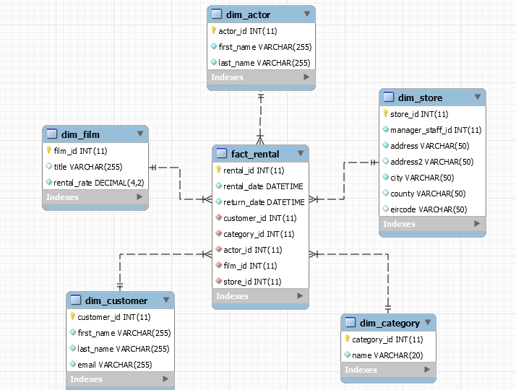

# SQL script to create tables

## Create Schema

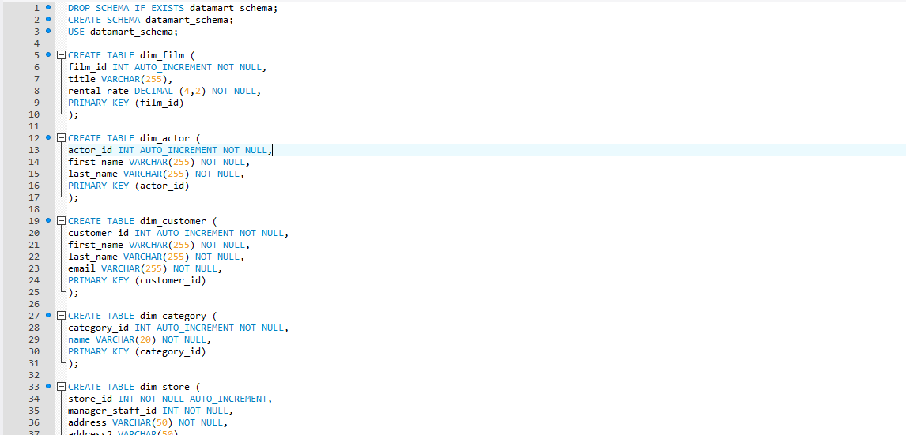

Continued ↓↓↓

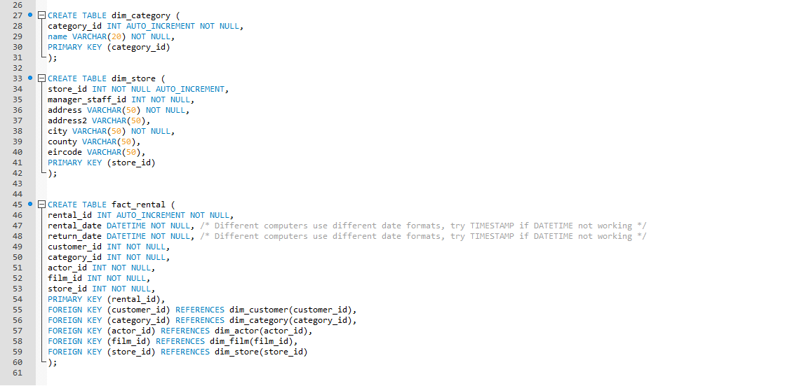

# SQL Script to Input Data

This is not the entire code, but one can see the first entries in full in the INSERT methods.

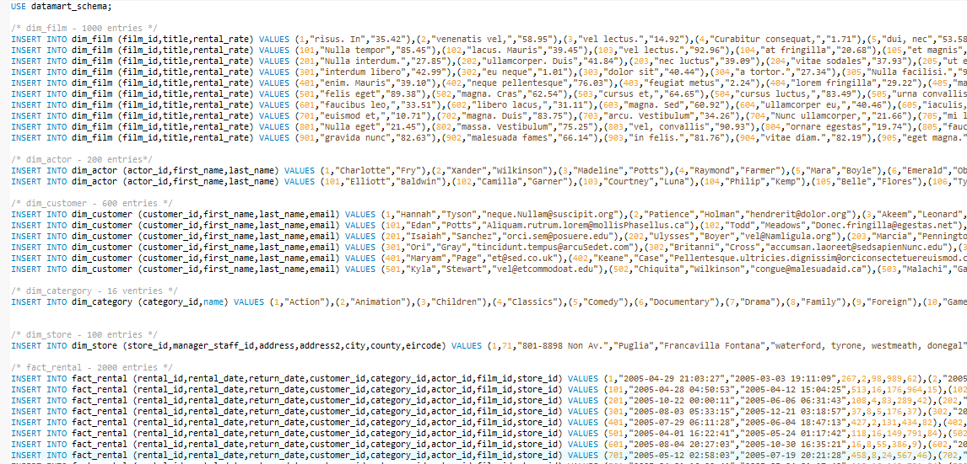

## Evidence of data creation

This is evidence of the group inputting data into GenerateData.com

## 

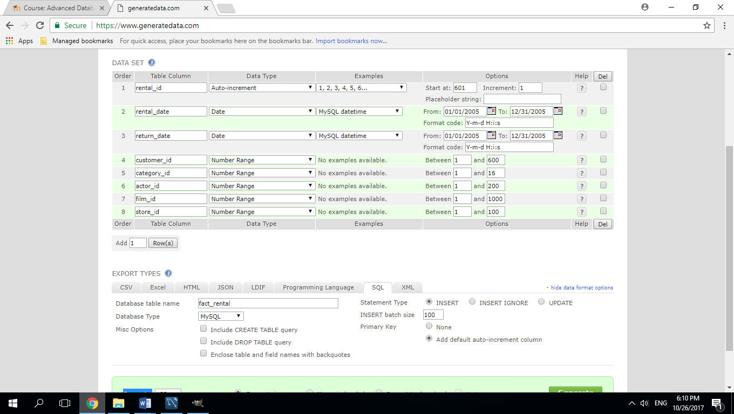

# Queries and their output

## Requirement 1; “For each Rental, list the email address of the Customer and which Store it was rented from / they are a customer of.”

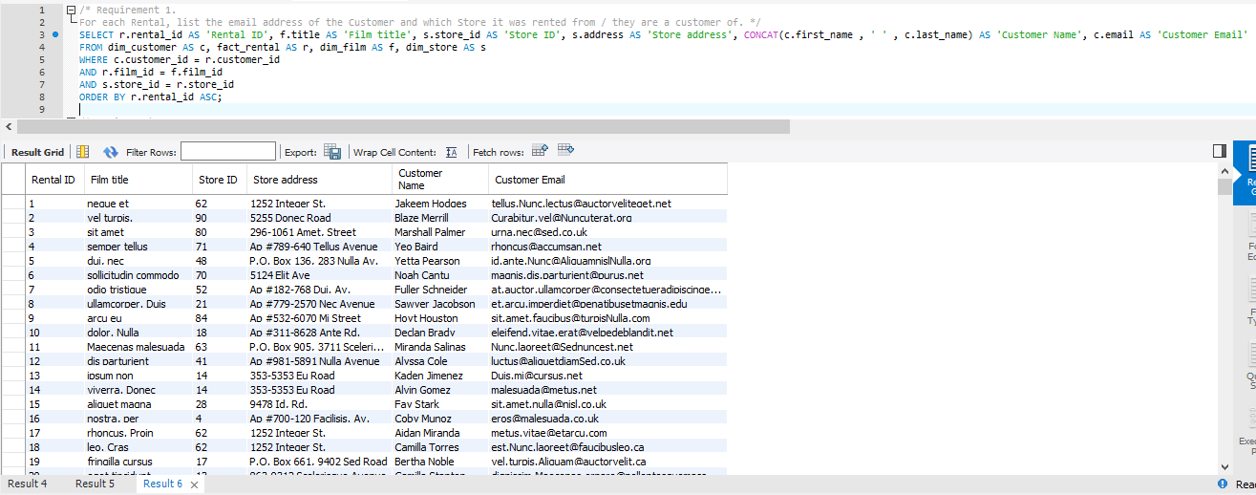

## Requirement 2; “List the least popular films (10) released in 2005 and list the actor for these films.”

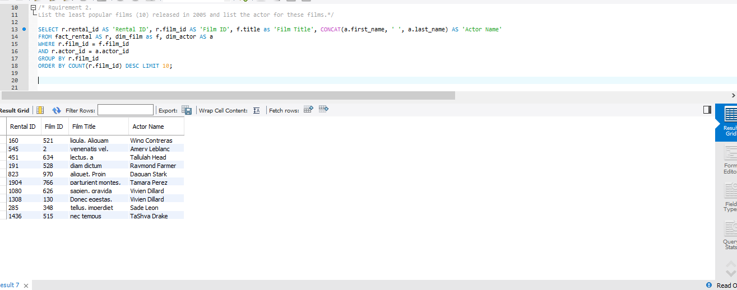

## Requirement 3; “Identify which films are currently on rent, and provide what Category.”

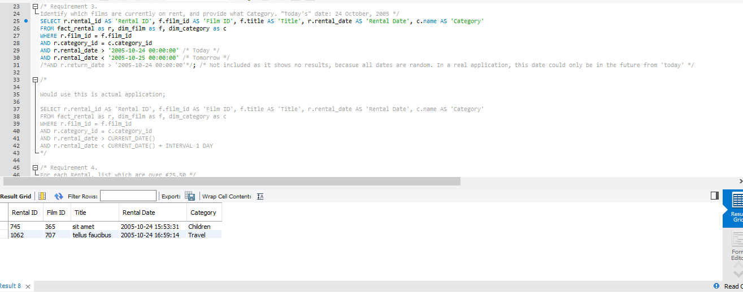

## Requirement 4; For each Rental, list which are over €25.50

